“Object Oriented Analysis and Design”



A
Lab Manual
Submitted to the
SAGE University, Bhopal, M.P.
in partial fulfilment of the requirements for the award of the Degree of BTech
(Hons) CSE Specialization in
Full Stack Development
IV Semester
By
Tanishka Soni (23BTA3BFS10030)

Under the Guidance of
Dr. Gourav Shrivastava Sir

DEPARTMENT OF ADVANCED COMPUTING
SANJEEV AGRAWAL GLOBAL EDUCATIONAL UNIVERSITY, BHOPAL
AUTUMN 2024-25

Use Case Diagram of Leave Management System
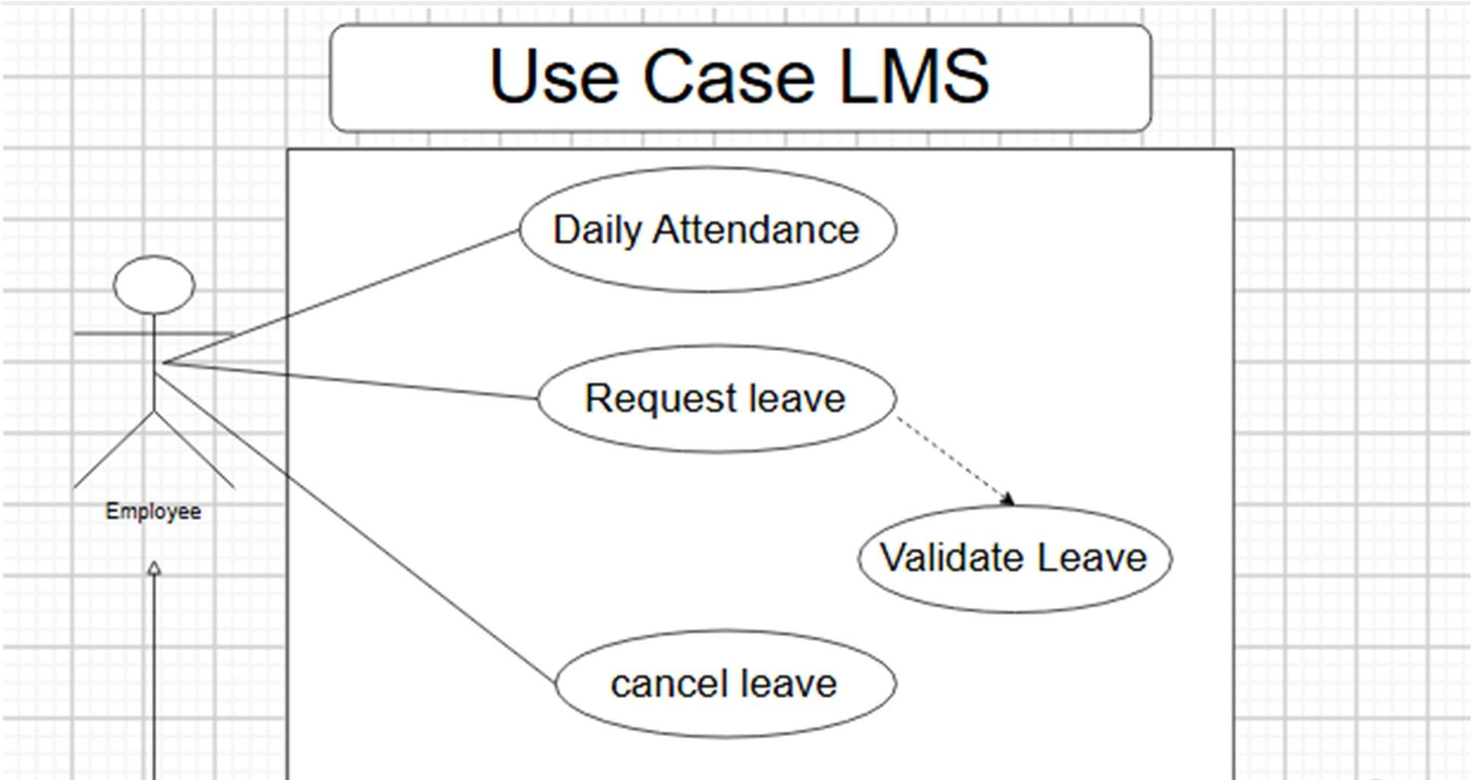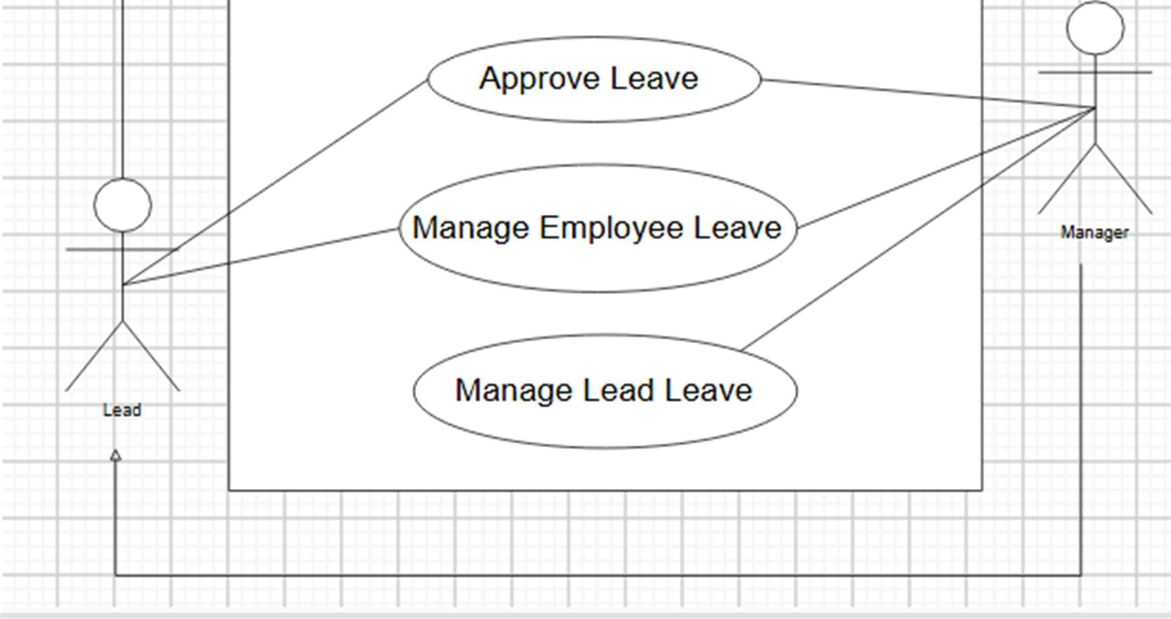

The Use Case Diagram of the Leave Management System represents the interac ons between various users and the system regarding leave ac vi es. Key actors typically include the employee, manager, and administrator. Employees can apply for leave and check their leave balance, while managers are responsible for reviewing and approving or rejec ng leave requests. Administrators have broader control, such as configuring leave policies and managing user roles. This diagram is crucial in visualizing the high-level func ons provided by a leave management pla orm.

Use Case Diagram of self checkout System
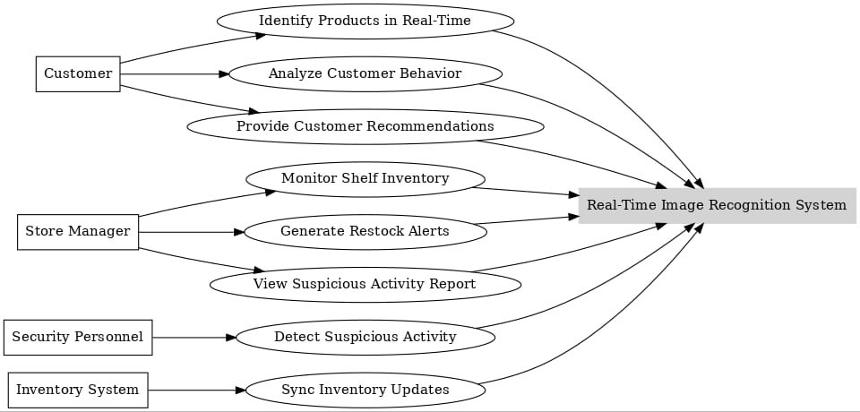
The Use Case Diagram of the Self-Checkout System illustrates how various users interact with a system designed to facilitate independent shopping and payment processes. The primary actor is the customer, who interacts with the system through a touchscreen interface, barcode scanner, and payment terminal. The system includes use cases such as scanning items, viewing the cart, applying discounts or coupons, selec ng payment methods, and comple ng the payment. Addi onal use cases may involve prin ng receipts, weighing items, and detec ng errors or mismatches (e.g., item not in bag). A store a endant or administrator may be involved in use cases like overriding age-restricted purchases, assis ng with system errors, replenishing receipt paper, monitoring transac ons, and upda ng product databases. This diagram helps visualize the func onal flow of a self-checkout system, commonly used in retail environments to improve efficiency, reduce wait mes, and enhance customer autonomy.

Class Diagram of ATM

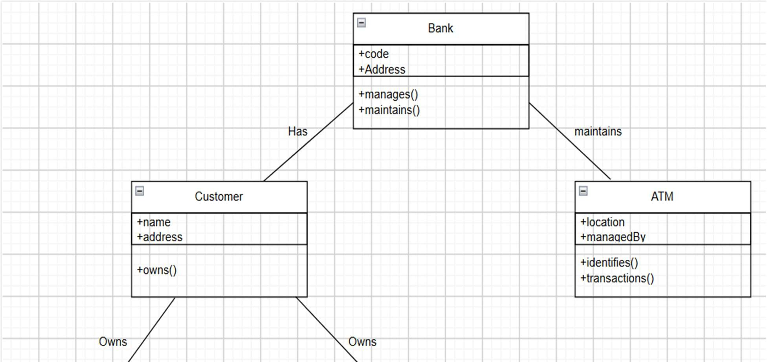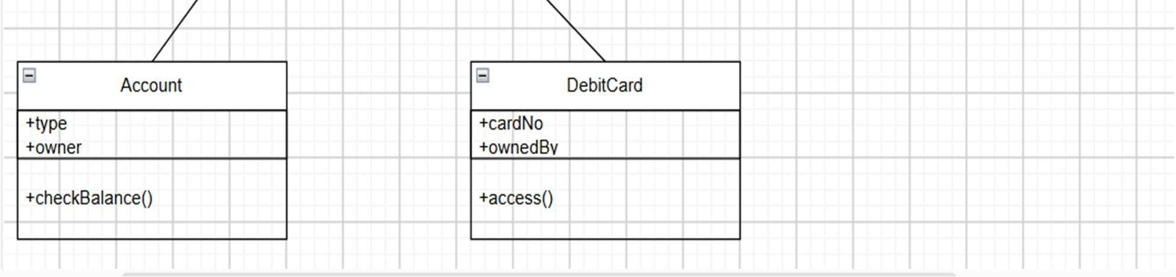

The Class Diagram of an ATM (Automated Teller Machine) illustrates the sta c structure of the ATM system by detailing the various classes involved and the rela onships between them. Core classes in the diagram usually include ATM, Bank Account, Card, Transac on, User, Screen, Keypad, Cash Dispenser, and Printer. The ATM class typically acts as the central controller, coordina ng interac ons between hardware and banking opera ons. The Bank Account class stores details such as account number, balance, and transac on history, with methods for withdrawal, deposit, and balance inquiry. The Card class represents user authen ca on creden als, o en associated with a user class that contains personal data. Transac on is o en an abstract class with subclasses like Withdrawal, Deposit, and Balance Inquiry, each represen ng specific opera ons. Hardware interface classes like Screen, Keypad, and Cash Dispenser model the input/output components. This class diagram provides a clear overview of the components required to implement an ATM system using object-oriented design principles.

Use Case of ATM

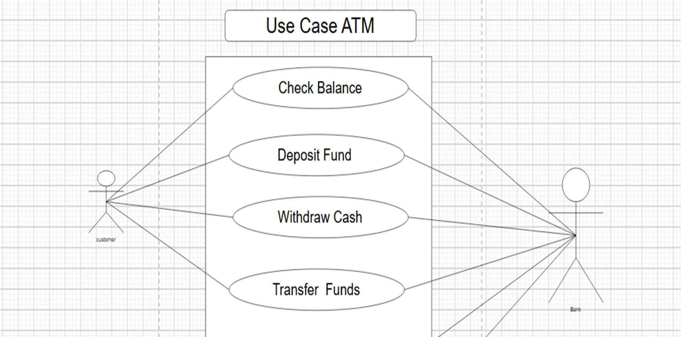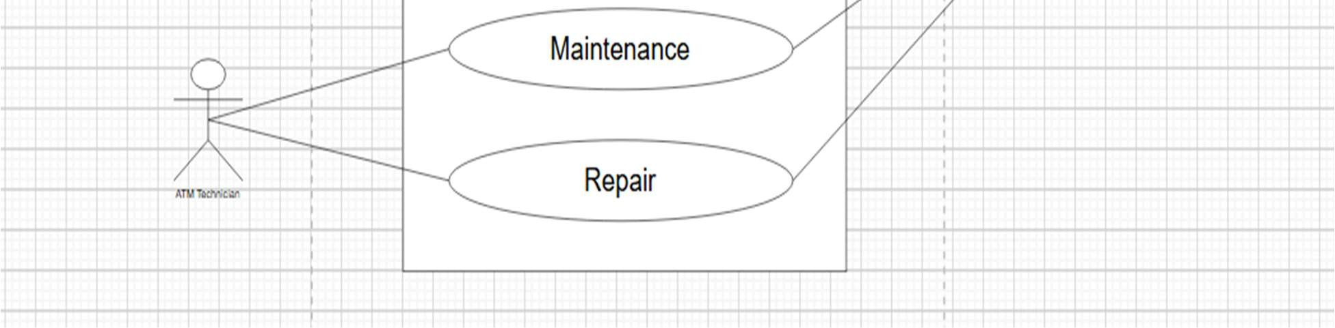

The Use Case Diagram of an ATM (Automated Teller Machine) depicts the interac ons between users and the ATM system, focusing on the services provided and the system’s func onal behaviour. The primary actor is the customer, who performs various banking opera ons through the ATM interface. Common use cases include Insert Card, Authen cate User (via PIN entry), Withdraw Cash, Deposit Cash, Check Account Balance, Print Receipt, and Transfer Funds. Each use case represents a service that the ATM system must support. Addi onally, there may be an interac on with a bank server or database system to validate transac ons, ensure account integrity, and update records. The use case diagram helps stakeholders visualize how the user engages with the ATM, making it easier to define system requirements and ensure a smooth user experience.

Class Diagram of Emo on Detec on System

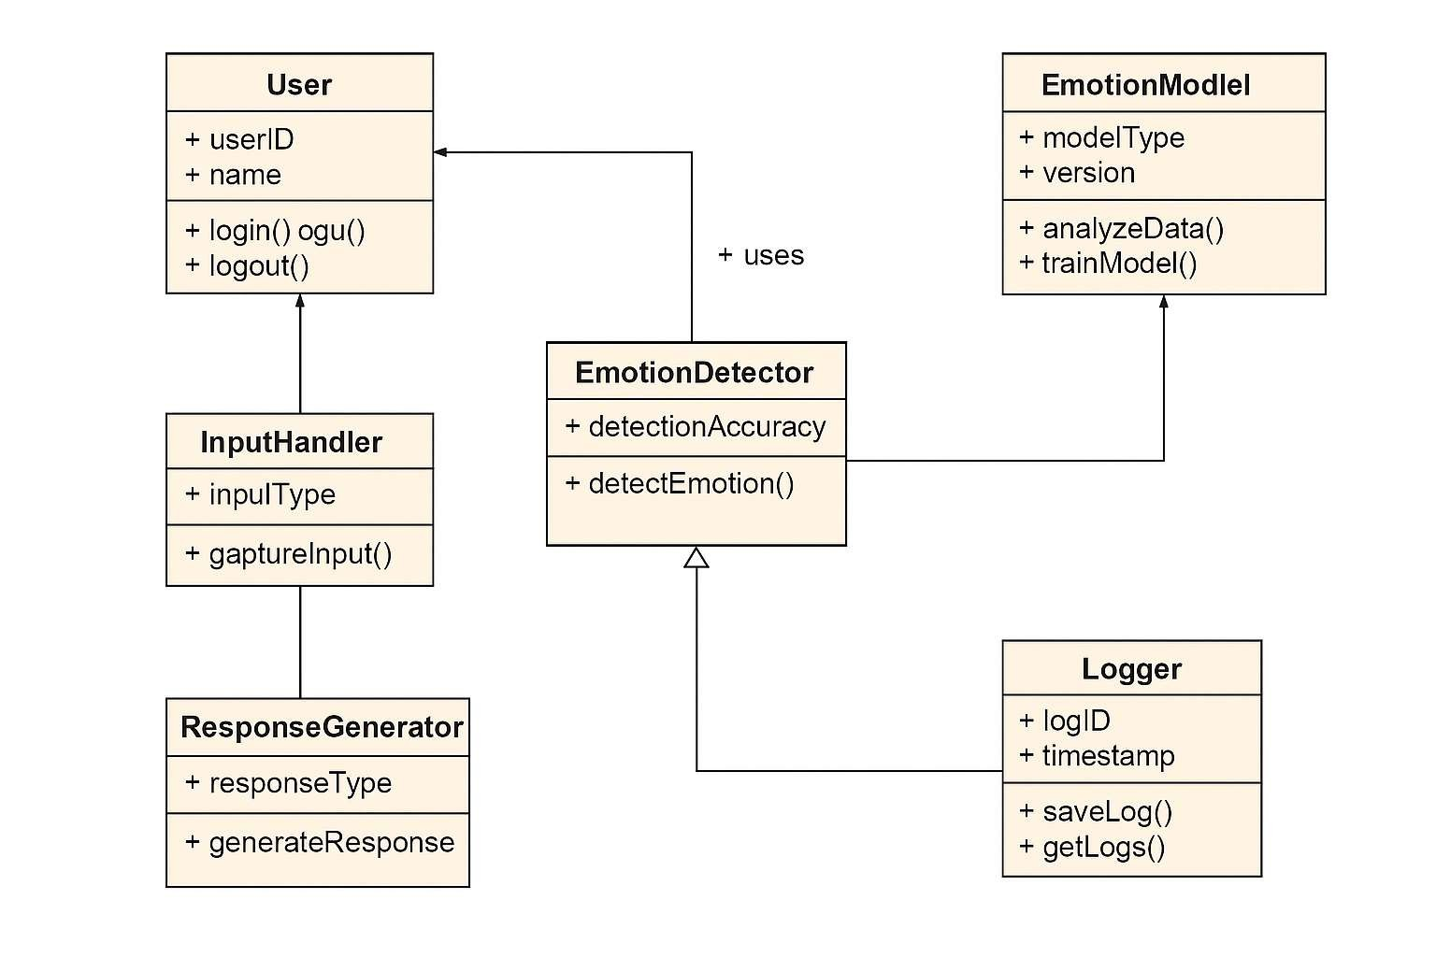

The Class Diagram of the Emo on Detec on System outlines the system’s structural components and how they interact to iden fy and process emo onal states. Key classes typically include User, Emo on Detector, Input Handler, Emo on Model, Response Generator, and Logger. The User class stores personal data and session informa on. The Input Handler class is responsible for collec ng data inputs such as facial expressions (via webcam), voice recordings (via microphone), or textual input. The Emo on Detector class acts as the core engine, interfacing with the Emo on Model—which u lizes machine learning algorithms to analyse inputs and classify emo ons such as happiness, sadness, anger, or surprise. Once an emo on is iden fied, the Response Generator class may take over to suggest appropriate ac ons or content (like music or mo va onal quotes). Finally, the Logger class stores detected emo ons and interac on history for analysis or feedback. This class diagram helps in planning and implemen ng an emo on-aware applica on by clearly defining object responsibili es and rela onships.

Ac vity Diagram of ATM
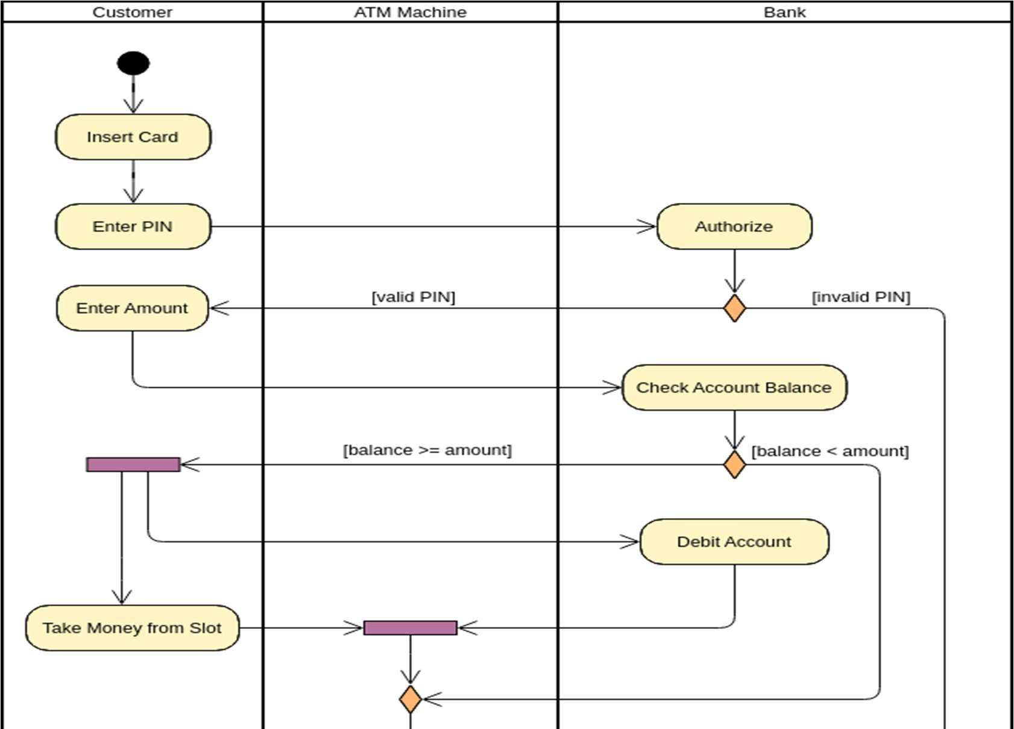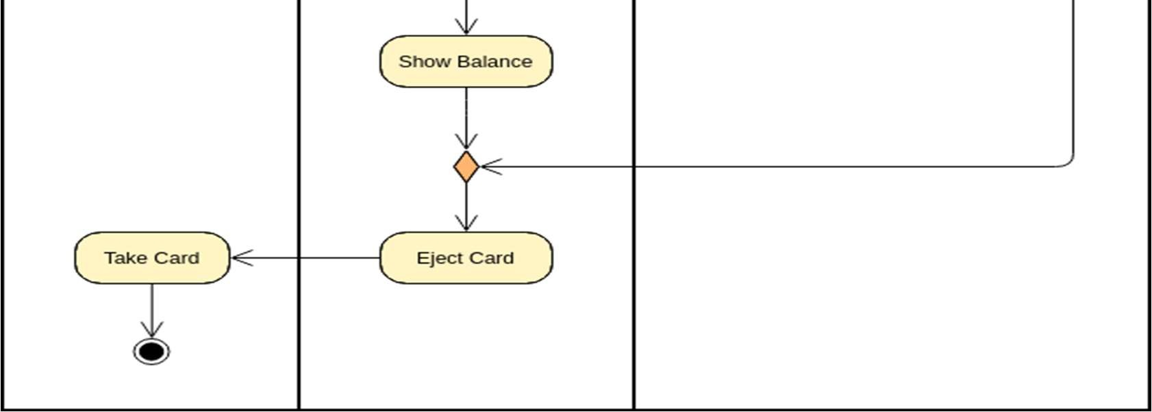

The Ac vity Diagram of the ATM models the sequence of steps a user follows when interac ng with the ATM machine. It begins with the user inser ng their card, followed by entering a personal iden fica on number (PIN) to authen cate. The user then selects a transac on type such as withdrawing cash, checking account balance, deposi ng money, or transferring funds. Depending on the selec on, the system processes the request by interac ng with the bank’s database. If the user withdraws cash, the cash dispenser releases the requested amount. A er the transac on is complete, the user is prompted to either perform another transac on or eject the card, ending the session. The diagram also includes decision points for valida ng PIN, checking account balance, and handling errors such as insufficient funds or incorrect PIN entry. This ac vity diagram visually captures the flow of control and decision-making involved in typical ATM opera ons.

Sequence Diagram of Library Management System

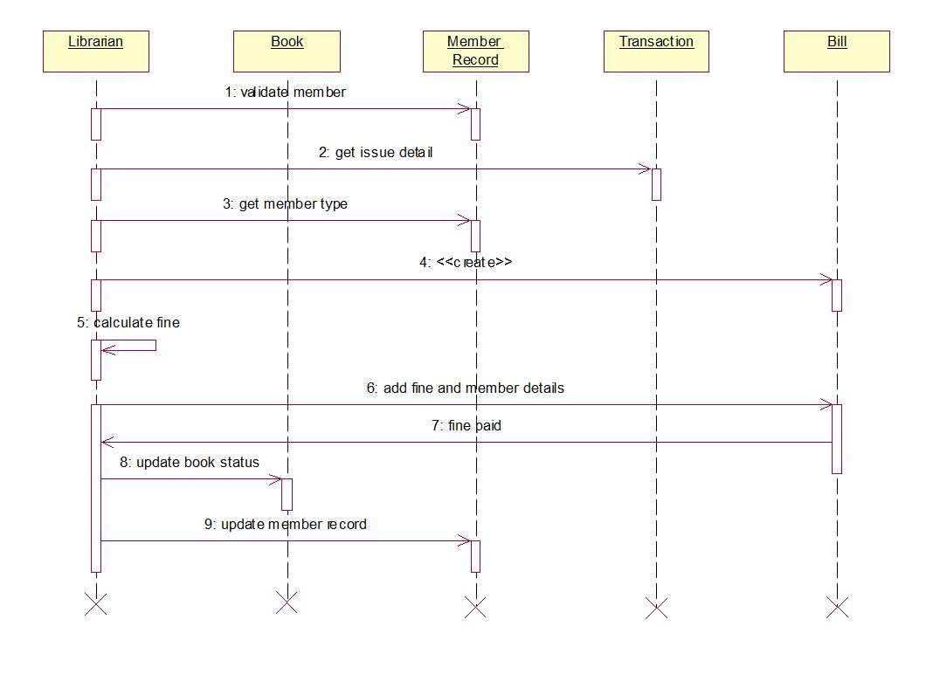

The Sequence Diagram of the Library Management System illustrates the interac on between various objects and actors during typical library opera ons. The main actors include the User and the Library System. The sequence begins with the user searching for a book, where the system queries the database for availability. If the book is available, the user can request to borrow it. The system then records the issue transac on and updates the inventory. Later, when the user returns the book, the system updates the records accordingly. The diagram captures the me-ordered flow of messages between the user interface, system logic, and database components, highligh ng processes such as searching, issuing, and returning books. This visualiza on helps clarify how system components collaborate over me to full fill user requests

Ac vity Diagram of Library Management System
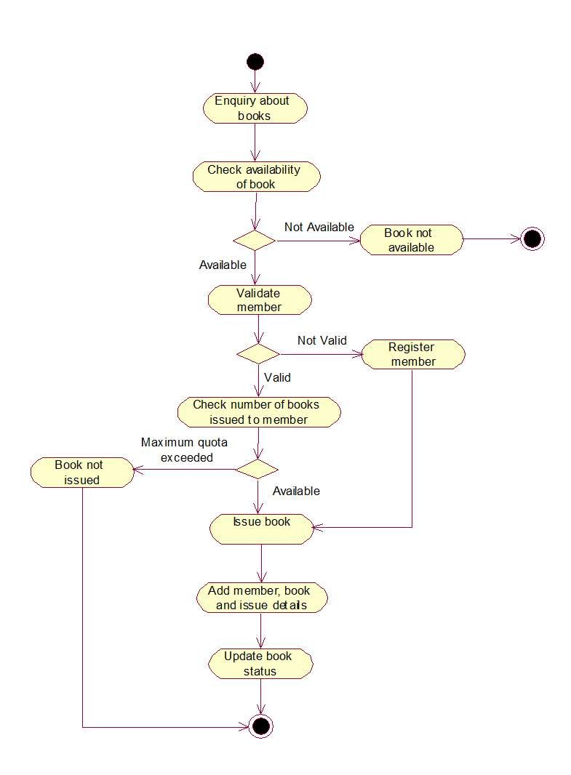

The Ac vity Diagram of the Library Management System depicts the step-by-step workflow involved in managing library opera ons. It starts with a user searching for a book in the system. If the book is found and available, the user can proceed to borrow it; otherwise, the system no fies the user about the unavailability. Once the book is issued, the system records the transac on. Later, the user returns the book, which the system processes by upda ng the inventory and transac on history. The diagram includes decision points for availability checks and user authen ca on, as well as ac vi es for issuing and returning books. This flowchartstyle diagram effec vely captures the logical progression of library management tasks, ensuring smooth and organized opera ons

Use Case Diagram of online Shopping System

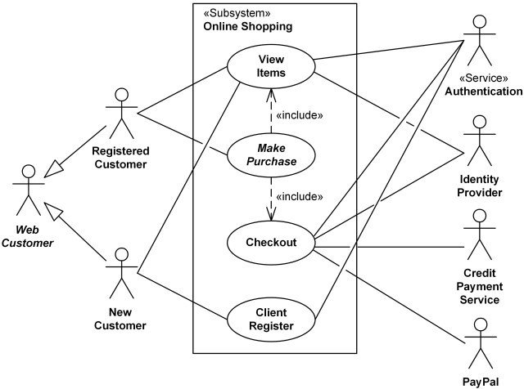

The Use Case Diagram of the Online Shopping System illustrates how different users interact with the e-commerce pla orm and the various services offered. The primary actors are the Customer, who browses products, adds items to the shopping cart, places orders, makes payments, and tracks deliveries; and the Administrator, who manages inventory, processes orders, updates product informa on, and handles customer service. Key use cases include Browse Products, Add to Cart, Checkout and Payment, Order Tracking, and Inventory Management. The diagram provides a clear overview of the system’s func onal requirements and the roles involved in delivering a seamless online shopping experience

Class Diagram of online Shopping System
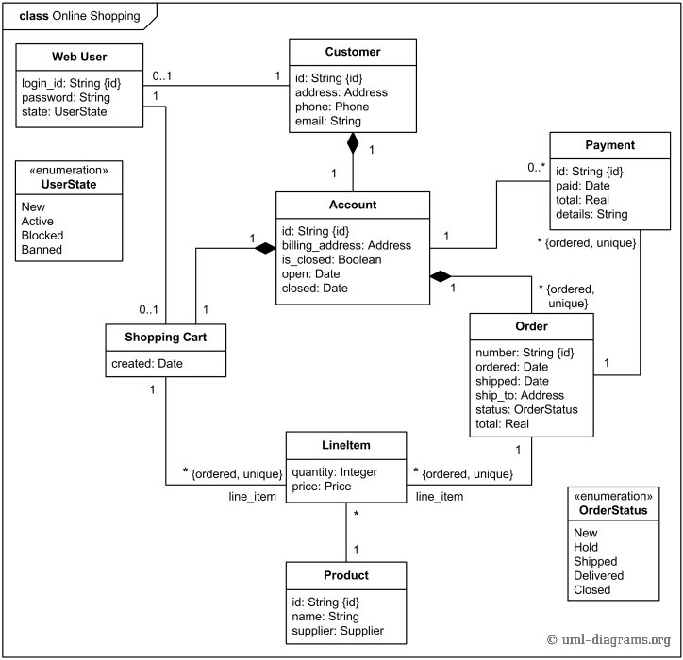

The Class Diagram of the Online Shopping System outlines the core classes and their rela onships within the e-commerce pla orm. Key classes include User, Product, Cart, Order, Payment, and Inventory. The User class stores customer details and authen ca on informa on. The Product class holds a ributes like name, price, and descrip on. The Cart class manages selected products and quan es before purchase. The Order class tracks purchase details, statuses, and delivery informa on. The Payment class processes transac ons, and the Inventory class manages stock levels. Associa ons between these classes represent interac ons such as users adding products to carts, placing orders, and payments being linked to orders. This diagram is essen al for designing the system’s data structure and suppor ng seamless online shopping opera ons

